Seminar Report

On

“INCREASING PRODUCTIVITY BY ELIMINATING WIRE BREAKAGE PROBLEM IN WIRE DRAWING PROCESS”

Submitted in partial fulfillment of the requirement for the award of the degree of

MASTER OF ENGINEERING

In

Manufacturing Systems Engineering

By

DARSHAN R. CHAUDHARI

Under the guidance of

Prof. Ramesh Rajguru

Professor, Mechanical Engg. Dept.



Shri Vile Parle Kelvani Mandal’s

D. J. SANGHVI COLLEGE OF ENGINEERING

DEPARTMENT OF MECHANICAL ENGINEERING

Academic year- 2018 - 2019

University of Mumbai



CERTIFICATE

This is to certify that the Seminar report entitled “INCREASING PRODUCTIVITY BY ELIMINATING WIRE BREAKAGE PROBLEM IN WIRE DRAWING PROCESS” is a bonafide work of “Darshan R. Chaudhari” submitted to the University of Mumbai in partial fulfillment of the requirement for the award of degree of Master of Engineering in Mechanical Engineering (Manufacturing Systems Engineering).

___________________________

Prof. Ramesh Rajguru

Prof. Mechanical Engg. Dept.

Project Guide, DJSCE

__________________________

Dr. K. N. Vijaykumar

Professor & Head

Mechanical Engg. Dept., DJSCE

__________________________

Dr. Hari Vasudevan

Principal, DJSCE

Abstract

Wire drawing is a metal working process used to reduce the cross-section of a wire by pulling the wire through a single, or series of, drawing dies. There are many applications for wire drawing, including electrical wiring, cables, tension-loaded structural components, springs, paper clips, spokes for wheels, and stringed musical instruments. However sometime there are so many problems occurs during drawing process, just like wire breakages, wear and tear of drawing dies, irregular size of drawn wire etc.

There are so many factors that can cause those type of problems, like defective raw material, improper machining, preprocesses, improper lubrication etc. So, to overcome those problems a proper set up of dies, preprocesses, suitable environment should be provided. In order to increase competitiveness in the global market modern wire factory are forced to seek new solutions in order to increase their productivity and reduce production costs while maintaining high quality of products drawn. Finally, the data will be collected from various techniques to rectify the problems occurring during the wire drawing process.

Introduction

Wire drawing process is of quite old fashion, the wire is prepared by shrinking the beginning of it, by hammering, filing, rolling or swaging, so that it will fit through the die; the wire is then pulled through the die. As the wire is pulled through the die, its volume remains the same, so as the diameter decreases, the length increases. Usually, the wire will require more than one draw, through successively smaller dies, to reach the desired size. The area reduction in small wires is generally 15–25% and in larger wires is 20–45%. The exact die sequence for a particular job is a function of area reduction, input wire size and output wire size. As the area reduction changes, so does the die sequence.

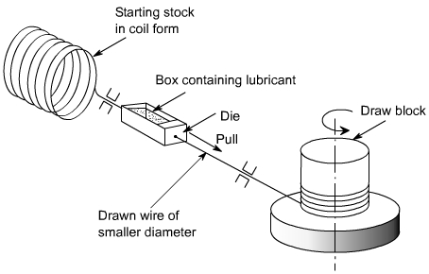

The main components of a drawing unit are Bull block, Die, die powder applicator, killing and casting rollers etc. A little bit of change in any factor related to equipment or material or machining process can affect on the final output of wire size. For having a brief idea about factors affecting the process we will have a look at the cause-and-effect diagram,

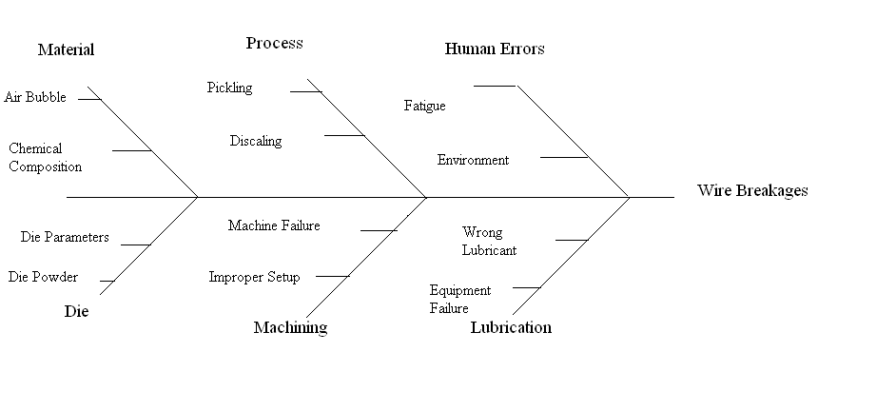

Those are the basic problems occurred during the wire drawing process. In any industrial segment, when a product is produced that does not meet the quality specifications, that is, that presents a defect, in addition to the waste of material used for manufacturing, several other resources are wasted. The labor required for production, time spent and the use of storage space are resources that are directly related to waste and that increase the costs of products when they are reworked.

Here we are basically focusing on the three main factors which are mostly responsible for wire breakages and those are.

1. Raw material
2. Wire Drawing Process
3. Wire Drawing Machine Equipment’s

We will collect appropriate data from process and then check weather is there any need for improvement in any process, material and equipment.

Our work is here to create a flawless wire drawing process which will not only increases the productivity but also reduces the amount of wastage.

Literature Review

Raw Material:

1) In this process high carbon steel and low carbon steels (Mild steel) of different grades are being used. Some of them are mentioned as,

|  |  |
| --- | --- |
| High Carbon Steel | Low Carbon Steel |
| HC 51/53 | SAE-1006 |
| HC 51/55 | SAE-1008 |
| HC 81/85 | SAE-1020 |
| HC 76/80 | SAE-1025 |
| HC 66/70 | SAE-1018 |

[Aly El-Domiaty](https://ezproxy.svkm.ac.in:2054/science/article/pii/S0924013698000454#!), [Sadek Z. Kassab](https://ezproxy.svkm.ac.in:2054/science/article/pii/S0924013698000454#!) have developed the theoretical work for different types of high carbon and low carbon steel materials to be choose according to the special purpose of wire. This work will help us to choose appropriate material selection.

Each of the material possesses different type of properties, which will be required for different kind of area of application. The composition of each type of material also varies according to the various content.

The use of high speeds in the wire-drawing process to meet the demands for increased productivity has a great effect on the heat generated due to plastic deformation and friction between the wire and the drawing tools. Most of the mechanical energy converts to heat and results in temperature rises of the order of hundreds of degrees. This temperature rise greatly affects lubrication conditions, tool life and the properties of the final product. The use of a proper lubrication technique substantially reduces the amount of heat generated during drawing and consequently reduces energy consumption. Energy saving in many metal forming processes, such as the wire-drawing process, became an important issue in a very competitive market. In order to achieve minimum energy consumption, the minimum possible drawing force had to be established by using the optimum die semi-angle, which in turn, has been established as a function of the area reduction and the coefficient of friction between wire and die. The predicted values for temperature rise were compared with the experimental findings in the literature to examine the validity of the prediction techniques.

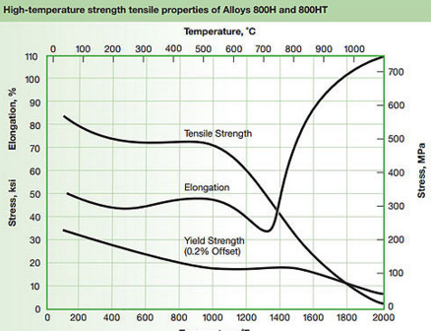

Above chart shows us that how temperature difference can cause a drastic change in physical and mechanical properties of a steel material, which will ultimately have effect on the performance of material and resulting into frequent breakages of wire during drawing process.

2) [Muharrem Yilmaz](https://www.sciencedirect.com/science/article/pii/S0924013605007387#!):

The toughness (draw ability) of the steel wire material should be high enough for a high output. Steel with a high cleanness will restrict problems during drawing and the heat treatment. In this study, the steel wires failures occurred during production or service have been investigated. The experimental data has been obtained in the studies starting from 1994 until present at the wire drawing companies located in Kocaeli area, Turkey. Kocaeli is the most industrialized area in northwest side of Turkey. One hundred and twenty-one failure case which have been investigated in our research center were involved in the study. The results and discussion of these failure cases are presented.

Wire Drawing Process:

1) L. Filice, G. Ambrogio, F. Guerriero

Drawing of wires is a well-known process and several manuscripts are recognizable looking at the scientific literature. The main reason why the process is used is related to increasing of the elastic resistance of the materials thanks to the induced yielding. The process was deeply investigated both from a numerical and experimental point of view. Luis et al. [1] reported a wide analysis within this frame. In the past, large efforts were spent in order to predict material breaking from a numerical point of view. In the paper here presented, a wide optimization model is proposed with the aim to demonstrate that material damage is just one variable to check and more efficient indexes can be run accordingly

2) Hyun Moo Baeka, Young Gwan Jin b, Sun Kwang Hwanga.

They had concluded that it was found that the numerical simulations matched well with the experimental results for an arbitrary introduced longitudinal surface defect for a multi-pass wire drawing.

In this study, a three-dimensional finite element analysis for multi- or single-pass wire drawing was carried out in order to evaluate the deformation behavior of various surface defects, such as longitudinal, transverse, oblique, and round, introduced during the manufacturing processes. Surface quality assurance of hot rolled wires is important because surface defects can develop into an external burst in the forged products during a secondary process of manufacturing, accounting for roughly 50% of raw material rejections, as reported by Huang et al. (2004). In a steel bar and wire production, the drawing process is normally introduced after rolling to reduce the diameter of the wire by pulling it through a single or series of drawing dies. During wire drawing, the surface defects transformed from the rolling process could survive or diminish depending on the processing condition. In industry-related applications, cutting or grinding might be necessary to remove such surface defects before wire drawing because the drawn wire can be used as both a final product and a source material for subsequent manufacturing like forging.

M. Suliga.

He has proved that the wire topography in the drawing process is characterized by a random anisotropy and the amount of directing the geometrical structure of the surface depends on the drawing speed.

Technical progress necessitates the producers of wire and wire products continuous improvement of manufacturing them. Another factor stimulating the development of drawing industry are economic considerations. Nowadays the main direction of development and modernization of wire drawing mills is the implementation of the technology of high-speed drawing process of high carbon steel wires that have been used in manufacturing of ropes, springs and steel cord. The main obstacle in the implementation of this technology is heating of the surface layer of the wire that leads to the deterioration of lubrication, premature wear of dies and a decline in property of wires below the applicable industry standards. From the literature and the author’s own research shows that poor lubrication conditions at high-speed drawing in traditional technology of drawing are associated with borax lubricant carrier that does not offer downloads and maintenance by drawing a sufficiently large amount of lubricant on the surface of drawn wires. The investigation of high speed multipass drawing process in conventional dies it has performed for high carbon steel wire grade C78D (0,79 % C). The drawing process of f 5,5 mm wires in the final wire of f 1,7 mm was conducted in 12 passes, in industrial conditions, by means of a modern multi-die drawing machine Koch KGT 25/12, using conventional dies with an angle of drawing 2a = 12°

Wire Drawing Equipment:

1) Wire Drawing Die:

T.H. Kim, B.M. Kim, J.C. Choi.

They studied that Die and tooling defects are one of the major sources of product defects. Corrective maintenance operations of extrusion dies are carried out on a regular basis, due to the occurrence of repairable defects. In cold-forming processes, failure must be considered before die design, because high working pressure acts on the die surface. One of the main reasons for die failure in industrial application of metal-forming technologies is wear. Die wear affects the tolerances of formed parts, metal flow and costs of processes, etc. The only way to control these failures is to develop methods which allow the prediction of the die wear and which are suited to being used in the design stage in order to optimize the process. In this paper, the wire-drawing process is simulated by the rigid-plastic finite-element method and the results used for predicting the die wear by abrasive-wear theory. The effects of the temperature rise on the wear profiles of the dies are investigated. The simulation results are compared with measured die profiles.

Abrasive wearoccurs when a hard surface or hard particles pass over a soft surface, causing

loss of material. However, the abrasive grooves can be found on the wear tracks of the sliding

friction between similar metals. It means that abrasive particles may be formed during the

wear process due to work hardening, phase transformations and third body formation at the

interface.

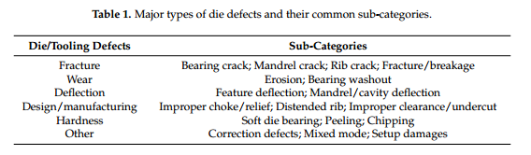

2) Viktor, Miroslav Zelenay, Lubos Kudelas

It was the influence on the mechanical properties (in our case on the breaking force) was not entire confirmed. At the same drawing conditions if we change die geometry, we can reach more than twice lower dies consumption.

The basic design solution of die is realized so that by drawn wire it covers the required precision of the dimension and the quality of surface. Unthinkable part of the die construction is its geometry.

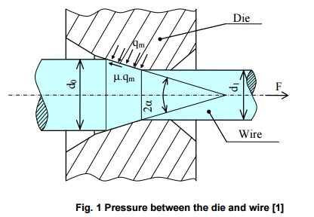

The experiment was in progress during 41 days of continual production and 650 t of wires of suitable quality were made. Chemical composition, mechanical properties and metallographic parameters of used heats of wire rod were very similar, without significant differences. In all machines it was used the same lubricating emulsion which was balanced by technological standard. During the experiment it was judged mechanical properties of wires, breakages and next wires processing, too

Problem Definition

In a wire drawing plant, the breakages of wire happen, that is a common scenario, but what if the failure occurs at a very high rate? Then that will become a headache to the manufacturer in terms of loss of productivity as well as profitability. The manufacturer wants the production seamlessly without defects, where everyone is aware and informed of outcomes and status.

Today we have too many release failures that results in too many rollback failures. If we ignore this problem; we may miss critical customer deadlines which could results in lost revenue, lost business, and further damage to our quality reputation.

The main problem is breakage of wire, this will happen due to following factors:

1. Raw Material
2. Drawing Die Problem
3. Flows in Drawing Process

For defining problem, we use 5’W’s concept.

1. WHO: Who does the problem affects?
2. WHAT: What are the boundaries of problem?
3. WHEN: When does an issue occurs?
4. WHERE: Where is the issue occurring?
5. WHY: Why is it important to fix the problem?

So, with the help of these concepts, we can define our problem and understand that what needs to be done.

Methodology

To carry out the research, a data collection form was applied to be filled out by quality professionals, when they blocked drawn bars or raw materials. Blocking consists of the identification, by means of a warning label, of non-conforming materials. Here are some types of high carbon wire rod with their chemical composition, mechanical properties

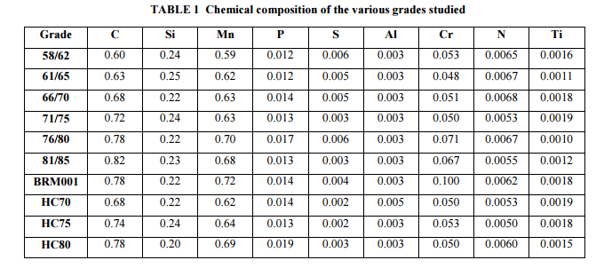

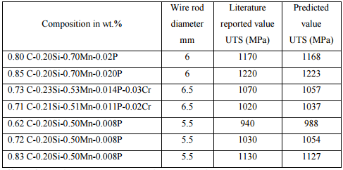

Table 2 Mechanical properties of various grades of wire rod

Now the various data has been collected from working machine by means of observing the wire breakage problem happening at what tine and in what mechanical condition.

The following data is being collected over a week from a single lot of 10MT of wire rod.

|  |  |  |  |  |  |  |
| --- | --- | --- | --- | --- | --- | --- |
| Day | Material | Die Problem | Process |  |  | Bull Block |
|  |  |  | Pickling | Descaling | Lubrication |  |
| 01 | 2 | 0 | 0 | 0 | 0 | 1 |
| 02 | 1 | 0 | 0 | 0 | 0 | 0 |
| 03 | 0 | 0 | 0 | 0 | 2 | 1 |
| 04 | 0 | 2 | 0 | 1 | 0 | 0 |
| 05 | 1 | 0 | 1 | 0 | 1 | 1 |
| 06 | 1 | 1 | 2 | 1 | 0 | 2 |

Form this data we can easily say that there are number of instances where wire breakages happen due to various factor, which will ultimately turn into loss of the manufacturer and drastic decrement in productivity. The scrap generation is also very large, so to overcome this problem we must have to find some solution which increases the productivity with decreasing breakages problem and reducing waste material which ultimately turns into increase in gruff profit for manufacturer.

From data we can say that there are approximately 21-time wire breaks in a week. An average operator has to stop machine thrice to remove the broken wire, joining to new end of rod, and again piercing it through die. This keeps machine for nearly 30 to 50 min .in an idle state, affecting overall efficiency of the machine resulting into loss in productivity. For, obtaining increased efficiency and maximum output form a single die we have to design a die with perfect geometry like die angle, land, die material, and maximum thermal coefficient. And we will get this by studying wire drawing process and its characteristics.

Following data is collected form an ongoing wire drawing process, as wire breaks, we calculate the die angle and land for getting information that at what are the geometric changes wire breakage problem takes place.

|  |  |  |  |  |  |  |  |  |  |  |  |  |
| --- | --- | --- | --- | --- | --- | --- | --- | --- | --- | --- | --- | --- |
| **Sr No.** | **Chemical Composition (%)** | | | | | **Die Angle**  **(Degree)** | **Land**  **(mm)** | **Lubrication Powder**  **(kg)** | **Tensile Strength**  **(MPa)** | **Yield Strength**  **(MPa)** | **Result** | **Reason** |
| **(Carbon)** | **(Mn)** | **(Si)** | **(P)** | **(S)** |
| 1 | 0.64 | 0.56 | 0.25 | 0.014 | 0.009 | 10 | 2.5 | 0.6 | 974 | 675 | ok |  |
| 2 | 0.64 | 0.56 | 0.25 | 0.013 | 0.009 | 10.4 | 2.5 | 0.6 | 974 | 675 | ok |  |
| 3 | 0.64 | 0.56 | 0.25 | 0.013 | 0.009 | 10.7 | 2.5 | 0.6 | 974 | 675 | ok |  |
| 4 | 0.64 | 0.56 | 0.25 | 0.013 | 0.009 | 10.9 | 2.5 | 0.6 | 974 | 675 | ok |  |
| 5 | 0.64 | 0.56 | 0.25 | 0.013 | 0.009 | 11 | 2.6 | 0.59 | 974 | 675 | ok |  |
| 6 | 0.64 | 0.56 | 0.25 | 0.013 | 0.009 | 11.5 | 2.6 | 0.59 | 975 | 675 | ok |  |
| 7 | 0.64 | 0.56 | 0.25 | 0.013 | 0.009 | 11.9 | 2.6 | 0.55 | 975 | 675 | ok |  |
| 8 | 0.64 | 0.56 | 0.25 | 0.013 | 0.009 | 12 | 2.6 | 0.55 | 975 | 675 | ok |  |
| 9 | 0.64 | 0.56 | 0.25 | 0.015 | 0.009 | 12.1 | 2.6 | 0.54 | 975 | 670 | ok |  |
| 10 | 0.64 | 0.56 | 0.25 | 0.015 | 0.009 | 12.2 | 2.6 | 0.54 | 975 | 670 | ok |  |
| 11 | 0.64 | 0.56 | 0.25 | 0.015 | 0.009 | 12.5 | 2.75 | 0.52 | 976 | 670 | ok |  |
| 12 | 0.64 | 0.56 | 0.25 | 0.015 | 0.009 | 12.7 | 2.75 | 0.51 | 969 | 670 | ok |  |
| 13 | 0.64 | 0.56 | 0.25 | 0.015 | 0.009 | 12.9 | 2.75 | 0.49 | 960 | 670 | ok |  |
| 14 | 0.64 | 0.56 | 0.25 | 0.015 | 0.009 | 13 | 2.82 | 0.49 | 980 | 670 | ok |  |
| 15 | 0.64 | 0.56 | 0.25 | 0.015 | 0.009 | 13.1 | 2.82 | 0.48 | 980 | 670 | ok |  |
| 16 | 0.64 | 0.56 | 0.25 | 0.014 | 0.009 | 13.5 | 2.82 | 0.48 | 980 | 670 | Not ok | Land |
| 17 | 0.64 | 0.56 | 0.25 | 0.014 | 0.009 | 13.5 | 2.82 | 0.47 | 980 | 670 | Not ok | Land |
| 18 | 0.64 | 0.56 | 0.25 | 0.014 | 0.009 | 13.5 | 2.87 | 0.45 | 980 | 670 | Not ok | Land |
| 19 | 0.64 | 0.56 | 0.25 | 0.014 | 0.008 | 13.9 | 2.87 | 0.45 | 980 | 670 | Not ok | Land |
| 20 | 0.64 | 0.56 | 0.25 | 0.015 | 0.008 | 13.9 | 2.87 | 0.43 | 980 | 670 | Not ok | Land |
| 21 | 0.64 | 0.56 | 0.25 | 0.015 | 0.008 | 14.2 | 2.87 | 0.43 | 980 | 660 | Not ok | Land |
| 22 | 0.64 | 0.56 | 0.26 | 0.015 | 0.008 | 14.6 | 2.9 | 0.4 | 980 | 660 | Not ok | Land |
| 23 | 0.64 | 0.56 | 0.25 | 0.015 | 0.008 | 14.6 | 2.9 | 0.4 | 980 | 660 | Not ok | Land |
| 24 | 0.64 | 0.56 | 0.25 | 0.015 | 0.008 | 14.7 | 2.92 | 0.39 | 990 | 660 | Not ok | Land + Die Angle |
| 25 | 0.64 | 0.56 | 0.27 | 0.015 | 0.008 | 14.9 | 2.92 | 0.39 | 990 | 650 | Not ok | Land + Die Angle |
| 26 | 0.64 | 0.56 | 0.25 | 0.015 | 0.008 | 15.1 | 2.92 | 0.38 | 990 | 650 | Not ok | Land + Die Angle |
| 27 | 0.64 | 0.56 | 0.25 | 0.015 | 0.008 | 15.3 | 2.95 | 0.36 | 985 | 650 | Not ok | Land + Die Angle |
| 28 | 0.64 | 0.56 | 0.25 | 0.015 | 0.008 | 15.5 | 2.95 | 0.36 | 985 | 660 | Not ok | Land + Die Angle + Lubrication |
| 29 | 0.64 | 0.56 | 0.25 | 0.015 | 0.008 | 15.6 | 2.96 | 0.35 | 989 | 670 | Not ok | Land + Die Angle + Lubrication |
| 30 | 0.64 | 0.56 | 0.24 | 0.015 | 0.008 | 15.6 | 2.97 | 0.35 | 983 | 670 | Not ok | Land + Die Angle + Lubrication |

From data we can say that there are approximately 21-time wire breaks in a week. An average operator has to stop machine thrice to remove the broken wire, joining to new end of rod, and again piercing it through die. This keeps machine for nearly 30 to 50 min. in an idle state, affecting overall efficiency of the machine resulting into loss in productivity.

References:

1) [Aly El Domiaty](https://ezproxy.svkm.ac.in:2054/science/article/pii/S0924013698000454#!) [Sadek Z. Kassab](https://ezproxy.svkm.ac.in:2054/science/article/pii/S0924013698000454#!). Journal of Materials Processing Technology.

2) L. Filice, G. Ambrogio, F. Guerriero. Procedia CIRP: Volume 12, 2013, Pages 294-299.

3) M. SULIGA. Prethodno priopćenje: Prihvaćeno 2016-08-30.

4) T.H. Kim, B.M. Kim, [J.C.Choi](https://ezproxy.svkm.ac.in:2054/science/article/pii/S0924013696022352#!). Journal of Materials Processing Technology: Volume 65.

**5)** Sheikh, A.K.; Khany, S.E. International Nuclear Information System (INIS).

**6)** Viktor, Miroslav Zelenay, Lubos Kudelas. for Materials Science and Technology: Brno, Czech Republic.

**7)** Hyun Moo Baek, Young Gwan Jin. Journal of Materials Processing Technology.

**8)** Wire Technology: Process Engineering and Metallurgy by Roger N Wright.